SMART MIRROR USING RASPBERRY PI

INTRODUCTION
A smart mirror is basically a mirror with a screen behind it. That screen can be an Android tablet or a computer monitor.
In recent years more and more devices are connected to the internet. The internet has played an important role in connecting more and more people across the world. Devices started to become smarter a smarter, mobile phones became smartphones and most importantly internet was connected to a variety of devices and the concept came to be known as the ‘Internet of Things’.
Every day we look at the mirror to check how we are looking or how our attire is while getting ready. By this we are psychologically interacting with the mirror. So, the idea of a mirror which can responds to your commands can excite anyone.
Our project aims at exploring other fields where this technology can be used. It aims at including this technology in a mirror, because in general people spend a considerable amount of time in front of a mirror.

PROPOSED METHODOLOGY
The proposed system is to design an interactive futuristic smart mirror with artificial intelligence using Raspberry Pi.
In the proposed system, the ability of the system to recognize face and provide details of the same, incorporates the theory of artificial intelligence. Interactive computing, with wirelessly connected embedded devices that are being used in various day– to–day activities. Based on this technology, many devices/products are now emerging and with this intelligence it is providing comfortable, secure and convenient personal services everywhere.
We are using python programming at the back end as Raspberry pi works only on python. Python is a high-level, general-purpose programming language.
The mirror is eventually a technologically augmented interaction device. The objective of designing the mirror is to provide a natural interface in the ambient home environment for accessing various services such as location based
weather, time, calendar etc.

COMPONENTS REQUIRED

- 18" x 24" Picture Frame
- Acer 1080p Monitor
- Raspberry Pi Kit
- 18" x 24" Two-Way Glass Mirror
- (OPTIONAL) Acrylic Mirror
- 90deg. HDMI Adapter
- 1.25" Wood Screws
- Wood Glue
- Super Glue
- Black Acrylic Paint 3/4" Plywood
- Keyboard and Mouse

FUNCTIONAL OVERVIEW
It works as a normal reflective mirror so that the user can use it as a regular mirror. The two-way mirror acts both as a reflective surface as well as transparent to display the updates.
Everyone using this mirror will get real time updates.
User will be able to give commands to the mirror using the microphone in the raspberry pi 3 for appliances control.
The proposed mirror is designed to perform
a) Mimic a natural mirror interface:
b) A flat monitor is used for the mirror display. A one-way mirror is used to provide real time display of what is located in front of the Smart Mirror using Raspberry Pi thereby mimicking the
function of a regular mirror.
c) Personalized Information services: Users will be able to obtain minute updates of latest news and public headlines, weather reports as well as get reports of our interests.
d) Customized management of profiles: Users can create their own profiles and store them in the system. According to this profile, customized services are provided to the user.

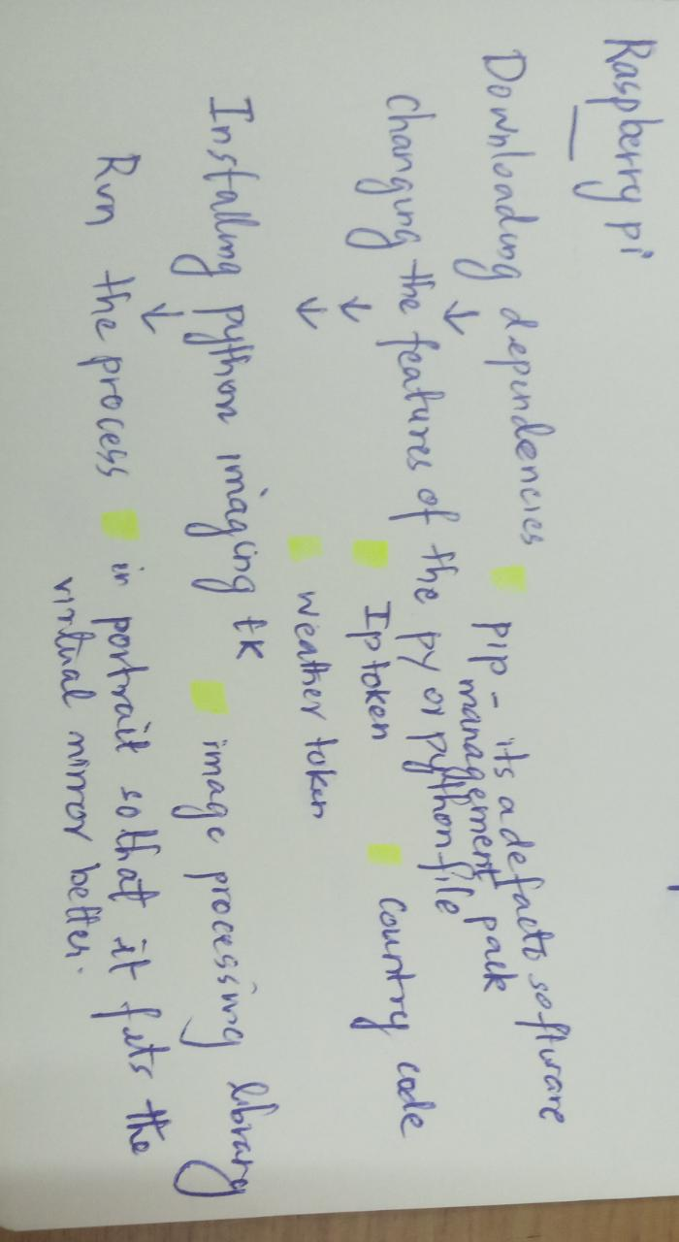

INCULCATION OF AI
Furthermore, in the course of the project the team is looking forward to inculcate AI components for facial recognition and speech to text vice-versa so that it allows the user to interact with the mirror. Conversion is not only it a smart but a self-thinking, self-taught mirror which satisfies a basic set oof requirement for the user.

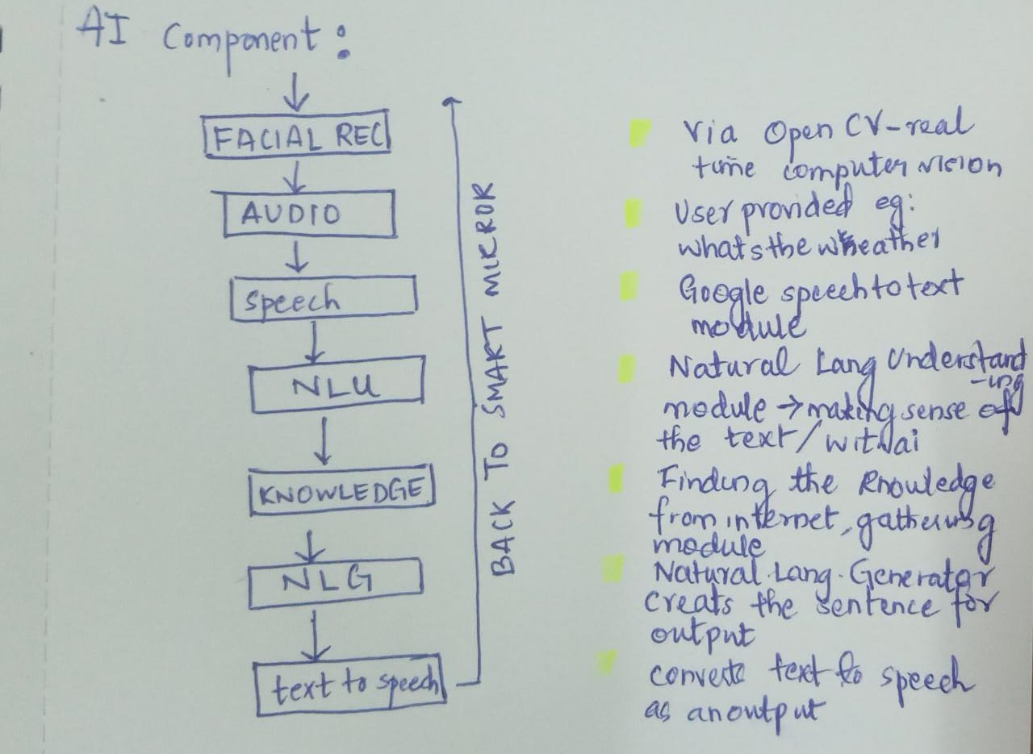
OUTPUT AND CONCLUSION
The output of the Smart Mirror has a black output screen which displays weather, news and time. The top right corner of the screen displays time which is present in the Raspberry Pi. It makes use the calendar for displaying the day and date along with time. The smart mirror can also be implemented in various industrial and home applications.
Hence IoT proves out to be an important technology for making household appliances smart. The facial recognition technology used in the smart mirror proves out to be an important means of security. Smart mirrors can be connected to home appliances and smart phones.
The mirrors can detect face and provide access to personalized services. The mirror can also be implemented to recognize emotions. The mirrors can be better enhanced to be deployed in beauty parlors, cloth shops, hotels, etc. with better advancements in technology, mirrors can be used in many other fields.

